Matt Domagala

Assignment2-Chapter3

#1, 2, 4, 5

<file:///E:/--OMIS%20475/MattDomagala_css1.html>

<!DOCTYPE html>

<head>

<title>Assignment 2; Chapter 3</title>

<style>

Body {background-color: #eaeaea; color: #000033;}

a {text-decoration:none;

background-color:white;

color:black;

font-famiy: Arial, Helvetica, sans-serif;

}

.new {font-weight: bold; font-style: italic;

}

</style>

</head>

<body>

<h1 style="background-color:black;color:white;"> Chapter 3 </h1>

<a href="https://www.niu.edu/index.shtml">Northern Illinois University</a>

<p style="background-color:green;color:white;">I know how to code. </p>

<footer class="new"> This is a new class. </footer>

</body>

</html>

#8

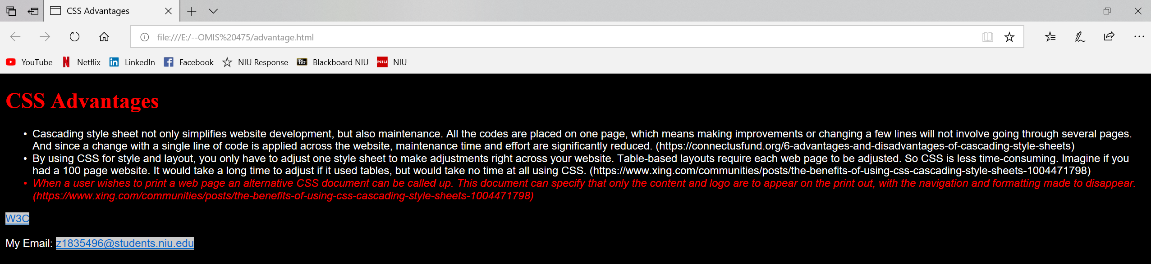

<file:///E:/--OMIS%20475/advantage.html>

body { background-color: black;

color: White;

font-family: Arial, Helvetica, sans-serif; }

a     { background-color: #CCCCCC; }

h1    { color: #CCCCCC;

font-family: "Times New Roman" }

.news { color: red;

font-style: italic; }

<!DOCTYPE html>

<html lang="en">

<title>CSS Advantages</title>

<head>

<meta Charset="utf-s">

<link rel="stylesheet" href="ex8.css">

</head>

<body>

<header>

<h1 style="color:red;"> CSS Advantages</h1>

</header>

<div id="page-wrap">

<ul>

<li>Cascading style sheet not only simplifies website development, but also maintenance. All the codes are placed on one page, which means making improvements or changing a few lines will not involve going through several pages. And since a change with a single line of code is applied across the website, maintenance time and effort are significantly reduced. (https://connectusfund.org/6-advantages-and-disadvantages-of-cascading-style-sheets)</li>

<li>By using CSS for style and layout, you only have to adjust one style sheet to make adjustments right across your website. Table-based layouts require each web page to be adjusted. So CSS is less time-consuming. Imagine if you had a 100 page website. It would take a long time to adjust if it used tables, but would take no time at all using CSS. (https://www.xing.com/communities/posts/the-benefits-of-using-css-cascading-style-sheets-1004471798)</li>

<li class="news">When a user wishes to print a web page an alternative CSS document can be called up. This document can specify that only the content and logo are to appear on the print out, with the navigation and formatting made to disappear. (https://www.xing.com/communities/posts/the-benefits-of-using-css-cascading-style-sheets-1004471798)</li>

</ul>

<a href="https://www.w3.org/">W3C</a><br><br>

My Email: <a href="https://outlook.office.com">z1835496@students.niu.edu</a>

</div>

</body>

</html>